Project Design Phase
Solution Architecture
Date | 19 February 2026
Team ID | LTVIP2026TMIDS35300
Project Name | Civil Engineering Insight Studio
Maximum Marks | 4 Marks

Architecture Overview

Civil Engineering Insight Studio

The system follows a simple AI-based architecture where the user interacts with a web interface, and the backend integrates with a Large Language Model (Gemini Pro Vision) to generate structural insights.

High-Level Solution Architecture Diagram
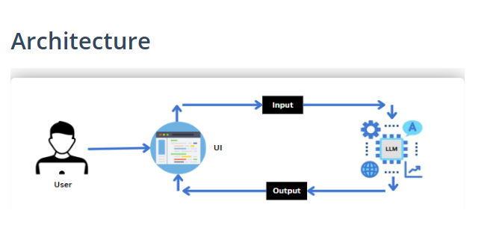

Detailed Component Architecture

1️⃣ User Layer

The user (civil engineer, supervisor, or student) interacts with the system through a web browser.

The user:
- Uploads a construction site image
- Enters a prompt for structural analysis
- Clicks the “Describe Structure” button

2️⃣ UI Layer (Streamlit Interface)

The UI is built using Streamlit and acts as the interaction layer.

It handles:
- Image upload
- Prompt input
- Input validation
- Display of AI-generated results

The UI sends the image and prompt as Input to the backend processing system.

3️⃣ Input Processing

The system prepares:
- Image in required format
- Structured analysis prompt
- API request configuration

The processed input is then sent to the LLM (Gemini Pro Vision API).

4️⃣ AI Processing Layer (LLM – Gemini Pro Vision)

The Large Language Model:
- Analyzes the uploaded construction image
- Identifies materials and structural components
- Understands the user prompt
- Generates a structured civil engineering description

The AI returns the processed response to the application.

5️⃣ Output Layer

The generated response is:
- Formatted properly
- Displayed on the UI
- Presented as structured structural analysis

The user receives:
- Type of structure
- Materials used
- Structural components
- Estimated dimensions
- Construction methods
- Project progress
- Engineering challenges

Technology Flow Summary

User
↓
Streamlit UI
↓
Input Processing (Python)
↓
Gemini Pro Vision API (LLM)
↓
AI Response
↓
Structured Output Display

Key Characteristics of Architecture

• Lightweight and modular design
• AI-driven processing
• No local database dependency
• Secure API communication via HTTPS
• Scalable for future enhancements

